**Concept Design Report**

# General Description

Firstly our strategy was going to be to go for the Lunar modules, however after much debate we thought that the clamp mechanism for the modules would be too complex and so would be more efficient to go for the Ores/balls. However in the appendix you will find some of our concept design sketches for this original strategy.

Now with our intention to go for the Ores our robot includes a rotating arm with brushes attached to it that is deployable on the front of the robot though a drawbridge mechanism. This rotating arm is intended to rotate in such a way that it hits the balls up a ramp into an internal storage area within the robot. For a more visual demonstration of this process in action please see this video from which our inspiration came - https://www.youtube.com/watch?v=bqFmPOUNUIM . Furthermore, the arm will be at such a height that the brushes only hit the larger ore balls rather than the moon rock and so means that our internal storage space is not wasted. The ball collecting arm is shows on sketches and initial CAD shown in the appendix. This storage area also has a second purpose of being an internal lift within the robot’s external wall that will be winched using servos up to a second higher location. This second location will be the height of the cargo bay so that the balls can be released from the side of the robot using an opening that be closed using hinged doors, off another ramp into the cargo bay. Again, this is demonstrated by concept sketches in appendix.

The obstacle and robot avoidance system for our robot will come in the form of an ultrasonic sensor attached to the front of the robot that will be coded to stop the robot when an object comes within a certain distance. The robot will wait for a certain time then check for objects again and then carry on or try moving in a different direction.

Finally, we intended to release the spacecraft for the funny action using a crossbow with a device that uses elastic potential for propulsion. There are sketches for how the will look and be release in the appendix section yet again.

# Design Innovation

We believe our design innovation comes in the form of the rotating arm ball collector as it is a simple and reliable solution to this problem. It will not damage the balls or not allow them to escape the robot that a shovel system might do. Furthermore, it allows the collection of many balls in one go as well as an inbuilt filter system that most of the time does not allow moon rock into our robot.

Another design innovation comes in the form of our self-correcting drive code that we intend to implement. This allows us to manoeuvre across the game board accurately and so reach the craters in the correct positon to sweep the balls into the storage area.

# Strategy map

For the Eurobot competition we have decided to prioritise the titanium ores. We feel that the lunar modules may take too long to place in the moon base. Also spinning the dual-coloured lunar modules to match our teams colour seems very difficult to implement.

On the strategy map we have colour coded our robots order dependant on our teams colour. If the robot starts in the blue area, it will follow the blue numbers, and if it starts in the yellow area it will follow the blue numbers.

Each crater has a lift around its edge that is 4mm in height. This shall be no problem for our wheels.

Firstly the robot shall head out of the starting area and towards area 1. This crater is prioritised over the other areas because it contains 20 titanium ores among 8 moon rocks. These titanium ores could yield 60 points if returned to the cargo bay as planned. This crater is situated approximately 2 meters away from the starting area. The robot will approach from the north of the crater. Accounting for time taken to get in and out of the starting area, we expect returning the titanium ores from area 1 to the cargo bay will take 40 seconds. This will be longest part of our journey, but also reward the most points. Currently we expect the robot to hold approximately 20 titanium ores in its internal storage area. This was calculated by assuming that our non-deployed robot will utilise the full 12000mm parameter and have an approximately 0.9m2 sized internal storage. This will score 60 points.

After depositing the titanium ores from area 1 to the cargo bay, the robot will then head to area 2. This area contains 5 titanium ores with no moon rocks. This area is closest to the starting area (approximately 0.2 meters away). The robot will approach from the south of the crater. Gathering the titanium ores and depositing them in the cargo bay will take 15 seconds. This will return 15 points.

The robot shall head to area 3. This crater contains 5 titanium ores and 1 moon rocks. This area is the lowest priority as it is furthest away and only containing 5 titanium ores along with 1 useless moon rock. Completing this will take approximately 35 seconds and return 15 points.

Finally the robot will complete its funny action after 90 seconds. This will ideally take place in the starting area after the robot has deposited the titanium ores from area 3 into the cargo bay. However, the robot will launch the rocket where ever it is after 90 seconds. This ensures we will still score the 20 points in the case that the robot gets stuck or takes too long to complete an action.

Our current plan would score us 110 points and would take the full time limit to achieve this. This strategy is still open to adaptation. For example if time permits after the UK final, we may implement a second robot that will focus solely on the lunar modules.

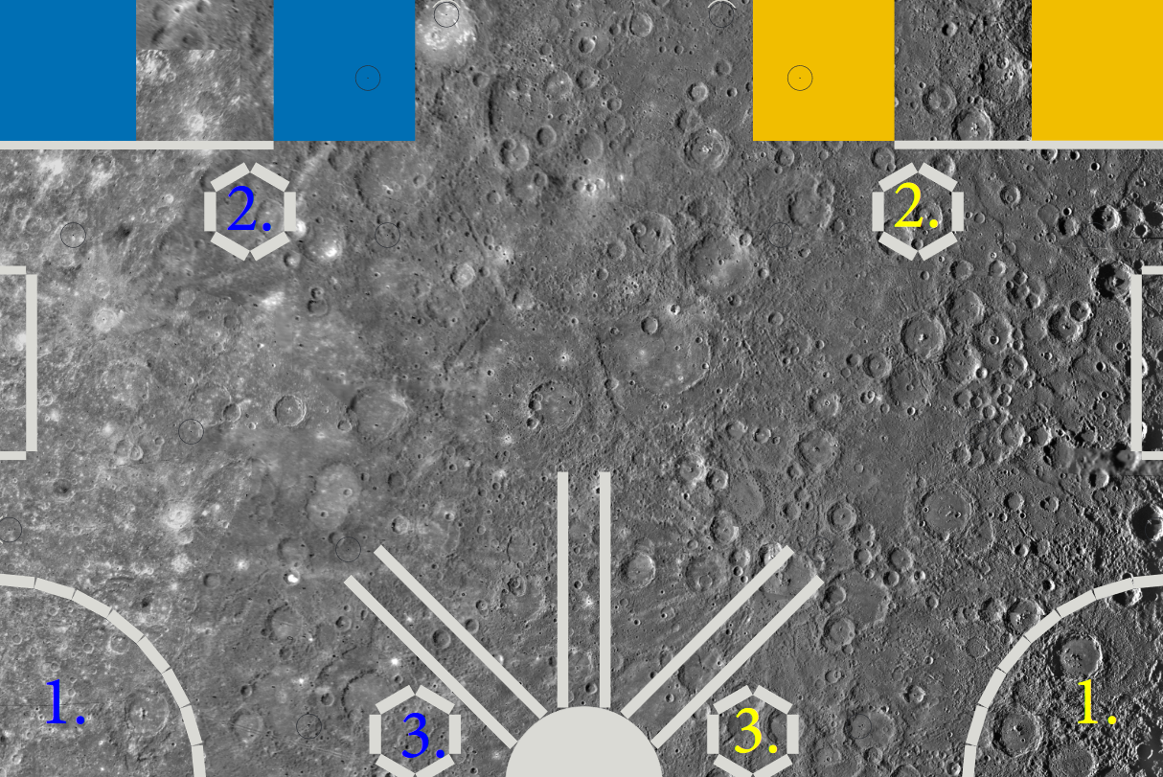

# Technical Description

**Power**

Currently we will be designing our robot to use a 12V 2Ah sealed lead acid battery since it is known to perform adequately in robotic applications on this scale, it is relatively simple to use and maintain with limited risk to the operator. The main disadvantage of lead acid batteries is their weight which will contribute to a large percentage of the overall robot weight; based on our testing during a previous odometry challenge we found that the added weight can cause the robot to carry too much speed at the end of its movements since it has more momentum. To counter this something we will be looking into is lithium polymer batteries due to their more lightweight nature and their potential for a higher capacity compared to the specified lead acid battery. Using a lipo will also allow us to easily use a voltage monitor to give an indication of remaining charge left in the battery so every round can be started with the same battery charge to reduce any variability in performance; to further this a voltage regulator will allow us to provide the drive system with a constant voltage.

Pb Battery Specifications:

150x20x89mm

0.7kg

**Microcontroller**

All team members are familiar with the arduino UNO microcontroller and the coding language to go with it, it therefore makes sense to use an arduino UNO to control the robot. Ideally we will only need to use 1 UNO since the robot will be designed with the limited I/O of the controller in mind however if it becomes unavoidable then 2 arduino UNOs will be used with the various tasks distributed between them.

**Drive System**

An MD25 dual H bridge motor driver board combined with 2 EMG30 motors. The motors are fitted with hall effect sensors which allow the MD25 to know the exact angular rotation of the motors which can then be translated into distance based on the wheel diameter. The hall effect sensors allow for active distance correction to be implemented by comparing the distance moved to the distance programmed.

If an alternative motor drive system becomes available through sponsorships then they will be looked into since the EMG30's feature a noticeable amount of play and the rate at which the hall effect sensors update could be improved to give a more consistent movement distance. Stepper motors could be a viable alternative which we will also look into further.

**Actuators/Sensors**

Ultrasound sensors will be used to detect the opponents robot, by placing the sensor above the height of the game pieces on our robot it should only detect the opponents robot. Since the playing area promotes the exploration of the other teams side of the board we aim to use an active beacon system to transmit a signal which our robot can use to judge distance and location on the board. The beacons will primarily be used to identify where on the board the opponents robot currently is, however they could also be used to direct our robot if it proves accurate enough.

To spin the ball collector brush a brushed dc motor will be used since they are the cheapest option of motor and the lower efficiency and lifespan compared to brushless motors will not be an issue for this application.

To control the various deployable parts of the robot a combination of servos and motors will be used. If the movement required is a high load then metal gear servos will be implemented due to their higher maximum torque. For all movements which only control a low load, plastic geared micro servos will be used due to their lower power drain and cheaper cost. For anything which requires a larger angular rotation or faster movement either a servo with a larger gear ratio or a motor will be used

Gantt%20Chart%20for%20Eurobot%20GDP.pdf

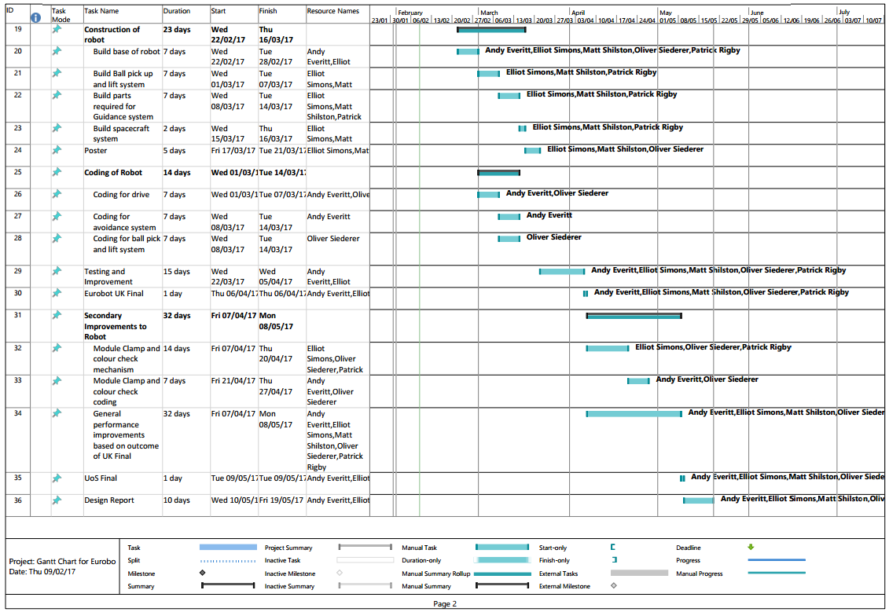

# Appendix

Overall Robot concept sketches

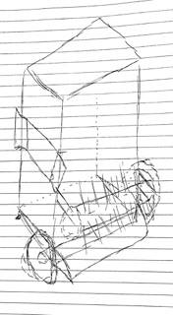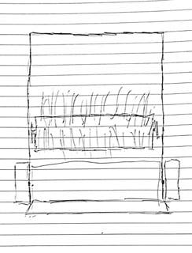

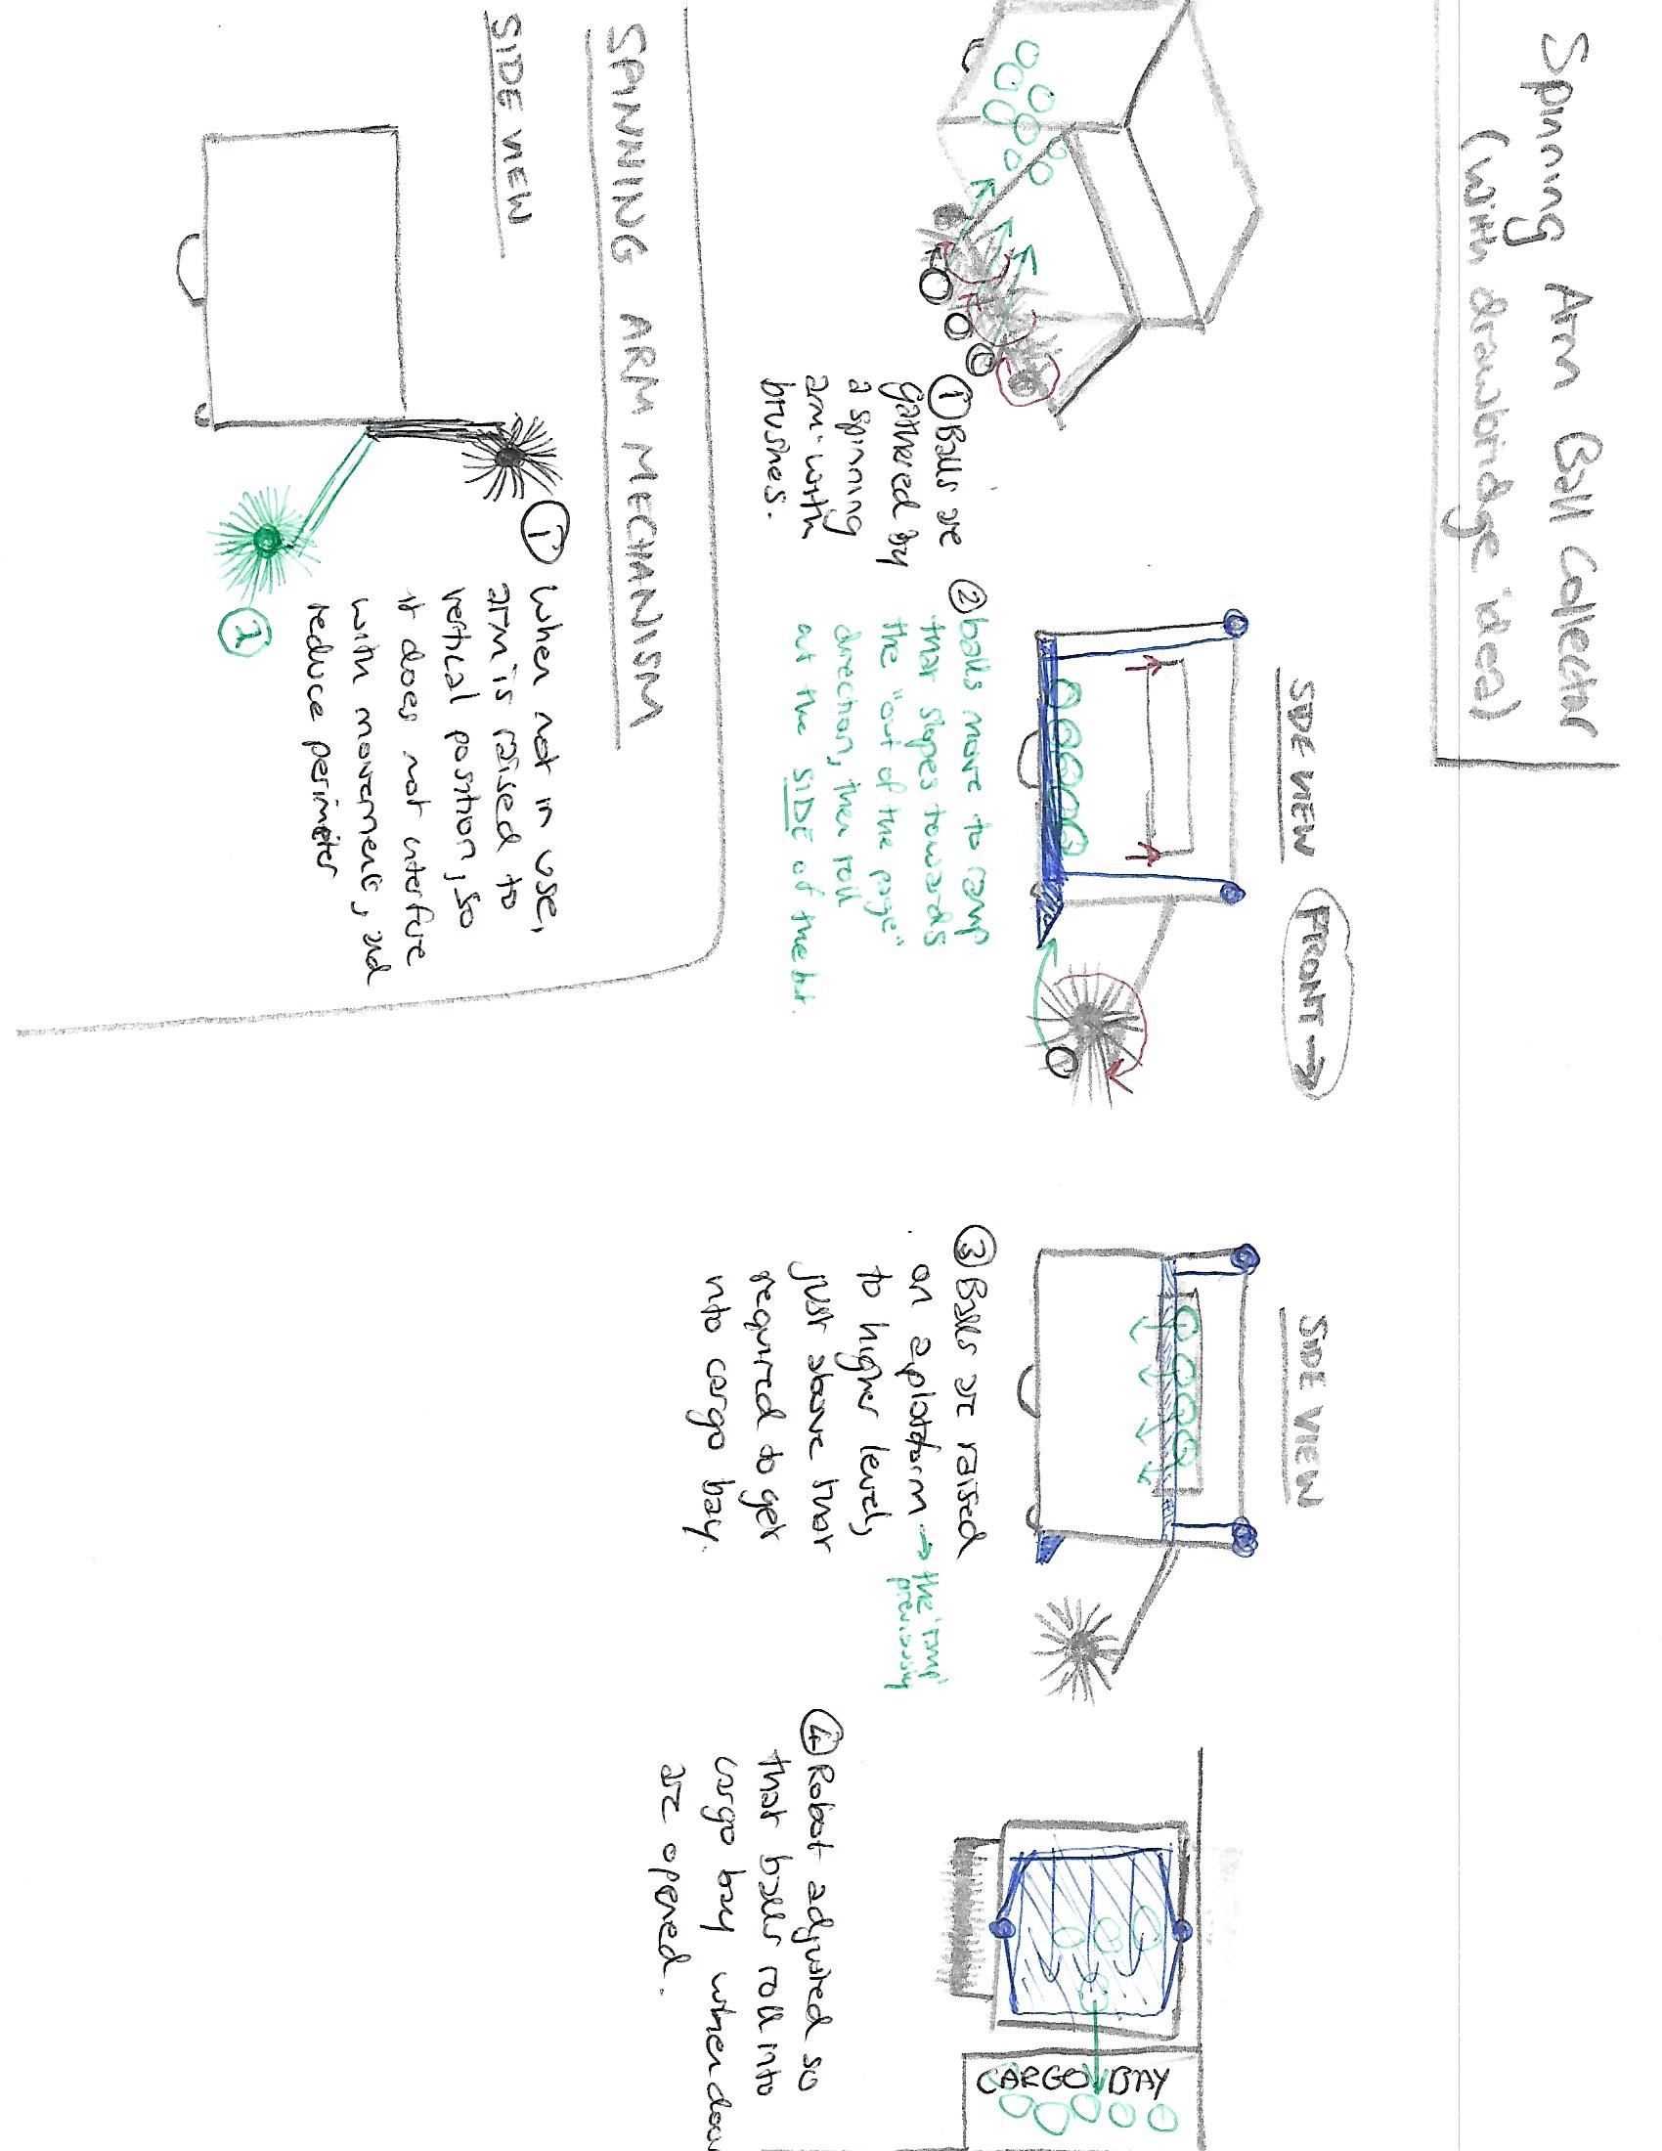

CAD designs for rotating arm ball collector

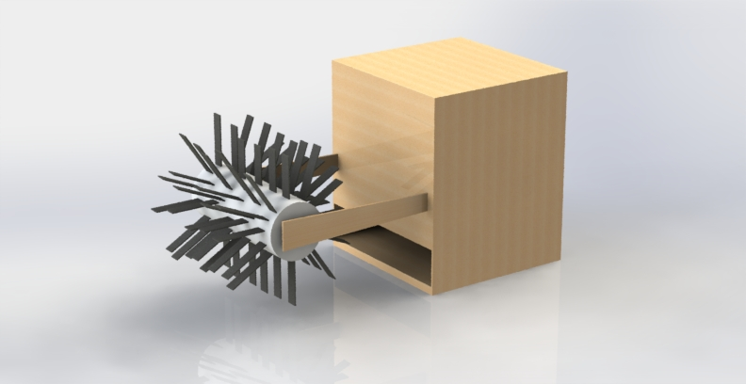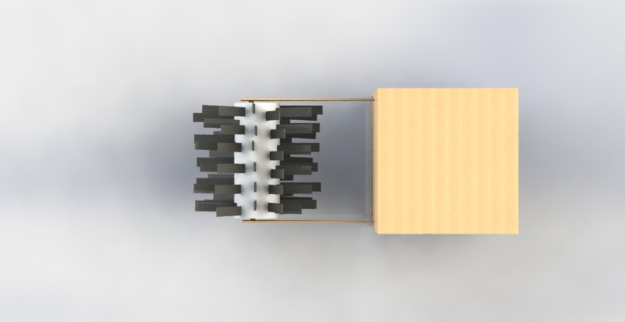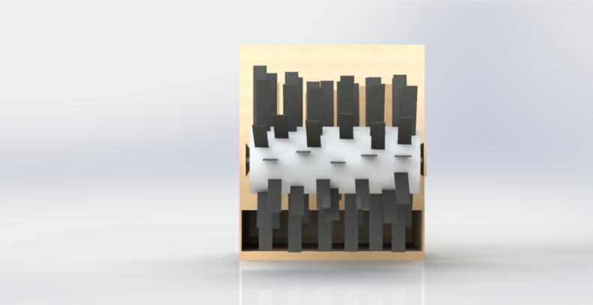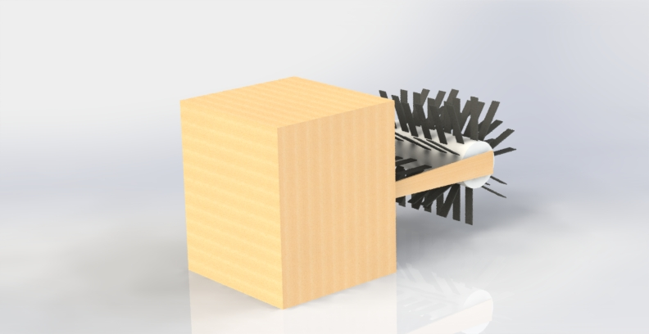

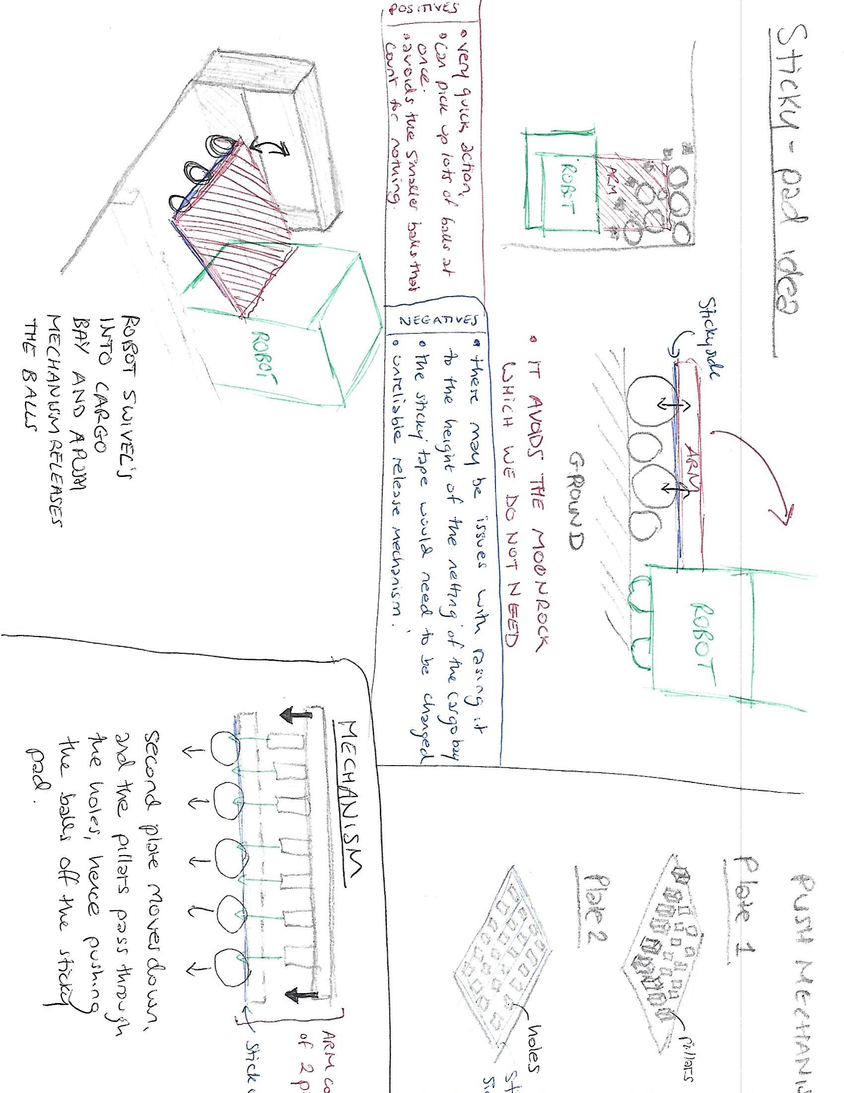Rocket%20Launcher.pdf